Printed on this ____ day of _______, 2026

To whom it may concern,

The purpose of this letter is to confirm that the bearer of this letter as stated below is a volunteer, coach or assistant coach with the Newmarket Baseball Association for the 2026 season.

We request that all of our volunteers, coaches and assistant coaches for House League, Select, Rep and Elite teams provide a Vulnerable Screening Check. Our coaches will be providing leadership and training to a team of approximately twelve players. All coach and assistant coach positions are unpaid volunteer positions.

Applicant’s Name: ___________________________

Applicant’s Address: _________________________________________________________

If you have any questions, or require anything further, please contact me.

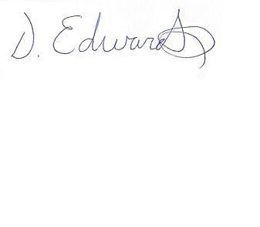
Sincerely,
Danielle Edwards
Administrator
Newmarket Baseball Association
admin@newmarketbaseball.com
905-715-7566 (office)

